import tkinter as tk

from pygame import mixer #pip install pygame

from tkinter import filedialog

import tkinter.font as font

from PIL import ImageTk, Image #pip install pillow

splash_root = tk.Tk()

# Adjust size

splash_root.geometry("512x575")

# Set Label

logo = ImageTk.PhotoImage(Image.open('.\\Logo\\logo.jpg'

))

logo_label = tk.Label(image=logo)

logo_label.pack()

splash_font = font.Font(family = 'Times New Roman', size = 30, weight = 'bold', slant = 'italic')

splash_label = tk.Label(splash_root,text="Know your music.", font = splash_font)

splash_label.pack()

def main():

splash_root.destroy()

mixer.init() # Initialize mixer

window = tk.Tk()

window.geometry('1190x595')

window.resizable(False,False) # Window not resizable

window.title('nPlayer'.center(370)) # Center Title

defined_font = font.Font(family='Helvetica')

songs_list=tk.Listbox(window,selectmode=tk.SINGLE,bg="black",fg="white",font=('arial',15),

height=21,width=109,selectbackground="gray",selectforeground="black")

songs_list.grid(columnspan=9)

my_menu=tk.Menu(window)

window.config(menu=my_menu)

add_song_menu=tk.Menu(my_menu)

my_menu.add_cascade(label="Menu",menu=add_song_menu)

def addsongs():

#to open a file

temp_song=filedialog.askopenfilenames(initialdir="Project\Music",title="Choose a song",

filetypes=(("mp3 Files","*.mp3"),))

##loop through every item in the list to insert in the listbox

for s in temp_song:

s=s.replace("Project\Music","")

songs_list.insert(tk.END,s)

add_song_menu.add_command(label="Add songs",command=addsongs)

def deletesong():

curr_song=songs_list.curselection()

songs_list.delete(curr_song[0])

add_song_menu.add_command(label="Delete song",command=deletesong)

def previous():

#to get the selected song index

previous_one=songs_list.curselection()

#to get the previous song index

previous_one=previous_one[0]-1

#to get the previous song

temp2=songs_list.get(previous_one)

mixer.music.load(temp2)

mixer.music.play()

songs_list.selection_clear(0,tk.END)

#activate new song

songs_list.activate(previous_one)

#set the next song

songs_list.selection_set(previous_one)

previous_button = tk.Button(window, text='Previous', command = previous, width = 25,

height = 4, font=defined_font)

previous_button.grid(column=0, row = 1)

def pause():

mixer.music.pause()

pause_button = tk.Button(window, text='Pause', command = pause, width = 25,

height = 4, font=defined_font)

pause_button.grid(column=1, row = 1)

def play():

song=songs_list.get(tk.ACTIVE)

mixer.music.load(song)

mixer.music.play()

play=1

play_button = tk.Button(window, text='Play', command = play, width = 25,

height = 4, font=defined_font)

play_button.grid(column=2, row = 1)

def resume():

mixer.music.unpause()

songs_list.selection_clear(tk.ACTIVE)

resume_button = tk.Button(window, text='Resume', command = resume, width = 25,

height = 4, font=defined_font)

resume_button.grid(column=3, row = 1)

def next():

#to get the selected song index

next_one=songs_list.curselection()

#to get the next song index

next_one=next_one[0]+1

#to get the next song

temp=songs_list.get(next_one)

mixer.music.load(temp)

mixer.music.play()

songs_list.selection_clear(0,tk.END)

#activate newsong

songs_list.activate(next_one)

#set the next song

songs_list.selection_set(next_one)

next_button = tk.Button(window, text='Next', command = next, width = 25,

height = 4, font=defined_font)

next_button.grid(column=4, row = 1)

# Set Interval

splash_root.after(3000,main)

# Execute tkinter

tk.mainloop()

Splash Screen:-

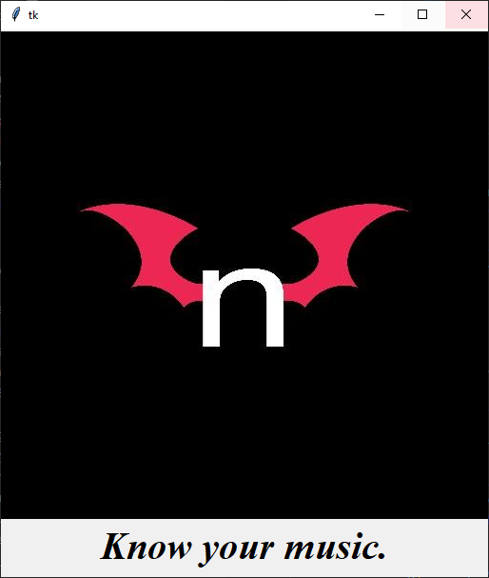

Main Window:

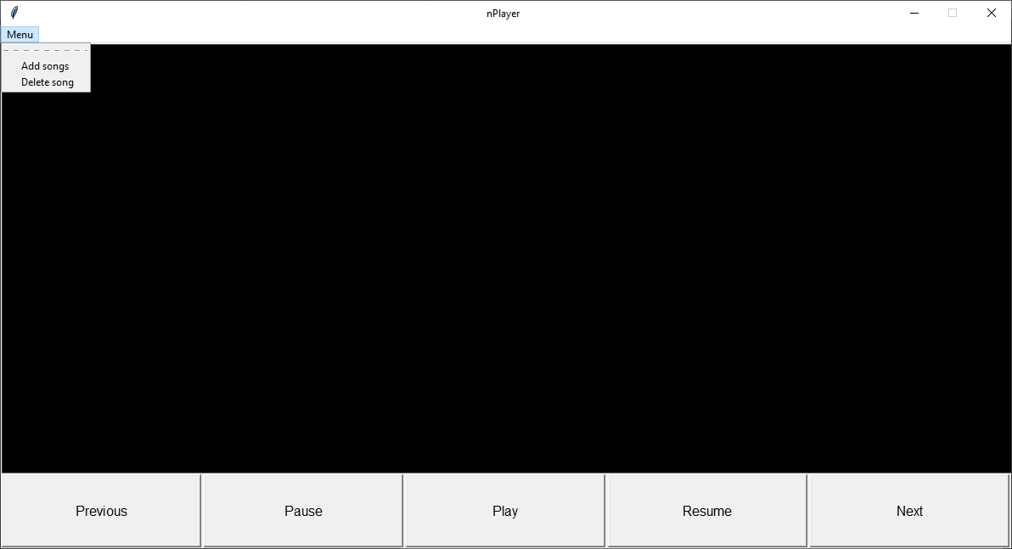

Adding Songs: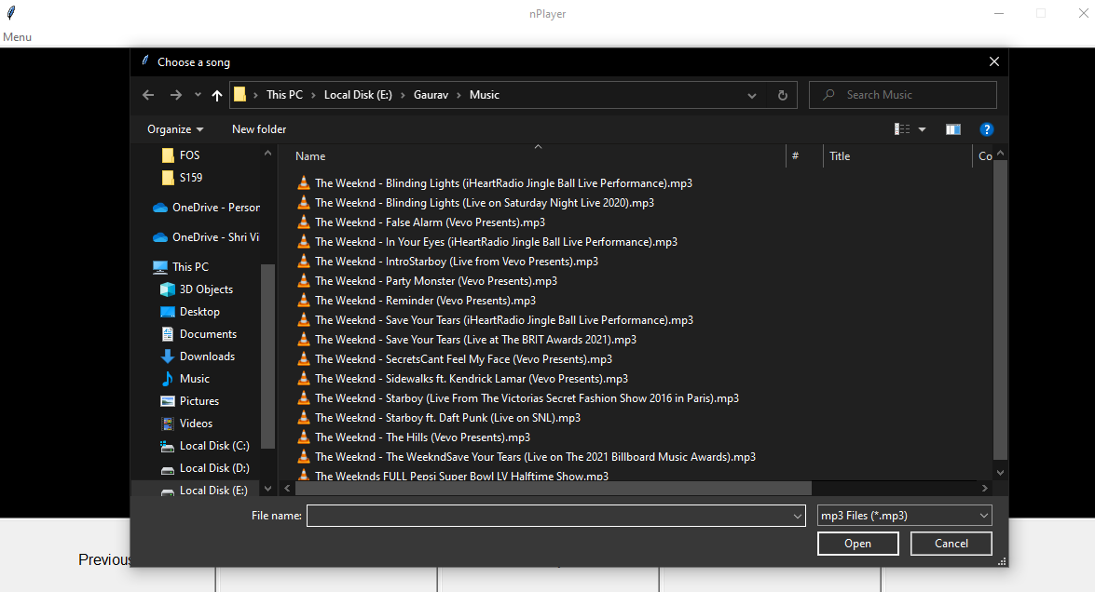

After Adding Songs:

